TÖL502M - Samskipti manns og tölvu

Group 10

23/11/20



HÓ2 - Competitive Card Game

Kim Stroem, Pétur Freyr Kristmundsson, Rökkvi Steinn Finnsson, Sigríður Ösp Green Sigurðardóttir

**1 - Challenge Description** **3**

**2 - Insight and Research Activities** **3**

Look 1 - A day in the Life - Rökkvi 3

Daily Overview 4

Thoughts 4

Look 2 - Personal Inventory - Sigríður Ösp 5

Interview Questions 5

Thoughts 7

Learn 1 - Historical Analysis - Kim 7

Using the Method 8

Discussion and Results 10

Learn 2 - Character Profiles - Pétur 11

Personas 12

Results 15

**3 - Ideation and Sketching** **15**

**4 - Prototyping** **16**

Prototype 16

Example flow 18

Results 21

**5 - User testing** **21**

Ask 1 - Narration - Pétur 21

Participants 22

The activity 22

Results 22

Conclusion 24

Ask 2 - Extreme User Interview - Kim 25

Questions 25

Discussion and results 27

Try 1 - Scenarios - Sigríður Ösp 27

Scenarios 28

Conclusions 30

Try 2 - user testing - Rökkvi 31

Conclusions 31

Interview guide 31

**6 - Conclusions and recommendations** **34**

# **1 - Challenge Description**

For the second group assignment we were tasked to create an app that’s engaging to children between the ages of 8-16. The key requirement was that the app gets children out of the house and engage with each other and society.

After our initial discussion and choosing Look/Learn activities it was decided that the group would meet up the next week with sketches and updates.

Document folder: <https://drive.google.com/drive/folders/17yVPBIA-3VQszut1KBVJyQ2hEvpiXrgg?usp=sharing>

# **2 - Insight and Research Activities**

## **Look 1 - A day in the Life - Rökkvi**

I decided to do the Look activity "day in the life" where I get an overview of how a day is in the life of the user. By doing this activity I hopefully get a little bit closer to an answer to questions like; does the user go outside regularly, does he meet his friends. Does most of his time go to playing computer games or watching youtube. I got in contact with one user that fits the user group and asked him to send me an overview of two days in his life just covering the main things he does and at what time. The overview was kept in Icelandic in order to change the original words as little as possible.

### 

### Daily Overview

**Day 1**

Fimmtudagur: vaknaði kl 08:00 fékk mér ristað brauð með eggjum og salami fór í skólann kl 08:50 og kláraði hann kl 11:50 og þá fékk ég karrýfisk til að klára skóladaginn og þá fór ég heim og tók klukkutíma slökun og fór síðan á hlaupaæfingu kl 13 og kláraði 14:15 fór þá og fékk mér rikki chan í kringlunni og fór heim og tók stutta styrktaræfingu og fór síðan í fifa 21 og síðan fékk ég mér góðan kvöldmat og slakaði síðan bara á að horfa á arsenal spila og síðan fór maður að sofa kl 22:30

**Day 2**

Föstudagur:

vaknaði fyrir skóla 08:00. fæ mér brauð og morgunmat, fer í skólan kl 08:50 til 1:50 og fór á einhvern tailenskan stað í Hafnarfirði í hádegismat og síðan slakaði ég bara á alveg þangað til í kvöldmat, fékk fisk úr fylgifiskum og spilaði fifa eftir mat og fór svo að sofa, þægilegur hvíldardagur

### Thoughts

After getting the results from the look activity I saw that my user is really active and does not watch tv all day. so I got an idea of an app. My idea is to create an app that works in a way that the user has to go outside and exercise, the user group are kids that are around 12 to 16 ish. Users have to sign up and try to collect as many points as they can, they get points by completing challenges and doing activities outside. The user can sign up to a group either with his friends or just some open groups like "Valur" for example. The only difference between open and closed groups is that everybody can be a part of an open group. the user collects points and tries to climb the scoreboard. The user registers a practice or a walk and gets X many points, users can send some motivation to each other and challenges. These challenges can be from not using the phone for a whole day, eating veggies each day for a whole week. There can be some kind of prize depending on the group the user is in. Then there can be bigger prizes. f.ex. If some company wants to sponsor the app and have a group of its own and offer some prices for the highest.

After the group got together and shared their thoughts, I got an idea that was a combination of each idea the group had. My idea was a combination of the games pokemon go and hearthstone. The idea was that you have to go outside and find cards that are scattered around Iceland. You can open the app and see if there are any cards near you and when you catch them you can add them to your deck, you then use your deck to challenge other players. There are challenges such as challenge a friend, find 4 cards, for completing the challenges players get gems which they can use to craft the cards they can't find.

## **Look 2 - Personal Inventory - Sigríður Ösp**

For this Look task I chose Personal Inventory. This activity focuses on learning more about people’s activities, perceptions and values by documenting things in their environment they find important. I asked my two cousins (13 and 16) to describe a few of their most used environments and situations and logged their answers. We discussed what items they take with them to school and when they go out, as well as what electronics they use, and what apps.

### Interview Questions

1. **School supplies**
   1. Question: What are the most important items you pack in your school bag?
      1. Sædís (13): Pencil case, school books, textbooks, hairbrush, phone
      2. Rhys (16): My notebook, pen, phone
   2. Both participants listed typical school items such as pencil case, notebooks, textbooks, etc. Sædís mentioned always having a hairbrush along. Both bring their phone to school but don’t get a chance to use it much as there are strict rules and they can get taken away.   
      In the current situation they are allowed their phones once classes are finished for the day.
2. **Out and about**
   1. Question: What items do you always take with you when you leave the house?
      1. Sædís (13): Phone, hand sanitizer, mask, hairbrush,
      2. Rhys (16): Mask, phone, wallet
   2. When out of the house both participants mentioned taking their phone and basic items such as wallet and mask. Sædís brings hand sanitizer and a hairbrush.
3. **On your desk**
   1. Question: What items are on your desk right now?
      1. Sædís (13): Pencil case, notebook, lamp
      2. Rhys (16): Books, clock
   2. This was the first item of discussion where the answers varied quite a bit. Sædís uses her desk mainly for schoolwork and lists items such as pencil case, notebook and lamp. Rhys on the other hand spends much of his time at his desk doing things such as using his laptop, reading, and playing games. He had just been reading so there wasn’t much on his desk other than books.
4. **Electronics**
   1. Question: What electronic device do you use most?
      1. Sædís (13): Phone
      2. Rhys (16): Laptop
   2. Sædís mainly uses her phone for social media, watching videos, playing games, etc. While Rhys prefers spending his time playing games on his laptop. He really enjoys the Five nights at Freddy’s franchise.
5. **Apps**
   1. Question: What apps do you most frequently use?
      1. Sædís (13): Tiktok
      2. Rhys (16): Youtube
   2. Both participants use their phones mostly for social media and watching videos. For chatting with friends and family they both use Whatsapp. Neither of them has facebook. Currently, Sædís’ favourite app is tiktok. She doesn’t post many videos but likes watching others channels. Rhys prefers browsing Youtube and has several favourite lets play channels that he watches.

### Thoughts

For the most part I don’t feel like much was learned from this exercise in regards to what to add to the application but I do feel like I’ve learned a lot about the participants’ environment and daily life which is useful when designing with a certain group in mind. I also got a crash course on tiktok which was very appreciated.

Both participants almost always have their phone with them. They use their phones mostly for watching videos, be it via Tik Tok or youtube. Maybe our app can include some form of videos to get kids out and interacting. Maybe posting your own doing some kind of challenge.

Doing this exercise really made me think about how testing is conducted when the participants are this young. Our interview was organized and supervised by my aunt so she was in the room during testing. This could definitely have affected my cousins’ answers, for example in regards to phone use at school or while studying. Me being their family member could also have affected their answers similarly.

## **Learn 1 - Historical Analysis - Kim**

The chosen IDEO Learn Activity was **Historical Analysis**. What this method attempts to achieve is, by letting one look to the past and also present patterns, project patterns into the future. The assumption is made that past and present patterns are related to patterns of the future and from this one can derive valuable information about the product or service one is designing.

This method of research should be very valuable for the task of finding a solution that can help kids and teenagers improve their physical and mental health. By looking at the past and present we could perhaps find trends that describe how the physical and mental health of kids and teenagers has developed as well as how the treatments and/or aid has developed along with it.

### Using the Method

When using the method it was decided to analyze historical and present ways that different organizations and companies have encouraged the physical activity and social engagement between youth. However we firstly want to look at the physical and mental health of youth from a *general* historical perspective in order to more closely understand the roots of the problem that we are attempting to find a solution for.

The importance of physical exercise has long been known to be of benefit to all people. Even as far back as 400 BC we hear Hippocrates speak of the benefit of physical exercise.

*“Eating alone will not keep a man well, he must also take exercise. ... And it is necessary, as it appears, to discern the power of various exercises, both natural exercises and artificial…”*

But while the idea of exercise and its benefits has long been obvious to people, its necessity and encouragement has only become more apparent as we have moved into more sedentary lifestyles. Public education for youth has since its inception encouraged physical activity and play (read: kids’ way of socializing) by the way of recess and physical education.

However the task is not only to combat the lack of physical activity amongst youth, but also to socially engage the youth. With the introduction of modern technology in the form of social media (YouTube, Facebook, Twitter, etc.) we have seen spikes in feelings of depression, anxiety, and loneliness amongst youth[1]. The way that social media complicates our task is that it has shown to have a strong correlation with having a small social circle. And it is in that way that social media has negatively affected those who use it, because people turn to social media for social needs rather than participating in person-to-person meetings.

It is clear that the issues caused by social media can be described as modern day issues. This knowledge lets us greatly narrow down the search for ways that organizations and companies have engaged youth.

As stated before, it is evident that the feelings of depression, anxiety, and loneliness that stem from social media means that social media is *not* a substitute for in-person connections. And furthermore it’s also evident that social media in and of itself does not promote physical activity. But worst of all we also know that social media's inherent addictiveness is not something that one easily breaks away from.

Therein lies the issue that society has been attempting to solve since the darker side of social media and our sedentary lifestyle has become more and more apparent. Social media presents addictiveness and the sedentary lifestyle is simply a side effect of the way our society is foundationally constructed.

Now that we more closely understand the backdrop we’ll start looking towards the ways that the presented issues have been tackled by organizations and companies.

A company that has for a long time worked with youth-targeted products (specifically video games) that oftentimes also involve physical exercise is Nintendo. In 2006 Nintendo debuted the Wii and along with the Wii came the game known as Wii sports. The Wii and the Wii sports combo was a marvel that took the world by storm (after all, Wii sports is one of the best selling games of all time). What the Wii leveraged was controls that made use of user movement (i.e. exercise), and Wii sports put those controls to the test. But not only did Wii sports encourage user movement it also encouraged multiple players to come together by the way of supporting multiplayer.

While Wii sports didn’t necessarily have users perform any extreme exercise it still proved the theory that you can combine fun, exercise, and games. Another weakness that the Wii did not provide that future products would be providing was a social platform.

One of the earlier recognized combined uses of the outdoors, social platforms, and modern technology would be Geocaching. Geocaching can be likened to a global treasure hunt where users can both hide and hunt “treasures”. Geocaching (as we know it today) was first introduced in the year 2000. Back then you’d go onto a website, acquire GPS data, and go out and find the “treasure” (caches) hidden by people. Geocaching has later evolved into making use of a phone app, but the core features have always stayed the same.

It should be noted that while Geocaching does leverage a social platform it misses two relevant key components (with respect to the task at hand) that would later be realized by other companies. Those two components are to actively push your audience to engage with each other and to appeal to the youth. This brings us to what may very well be seen as the modern pinnacle of products that encourage physical activity and social engagement of youth: Pokémon Go.

Pokémon Go is a mobile phone game that was released in 2016 to massive success. Despite being released over halfway into the decade it *still* turned out to be one of the decade’s most profitable games[2]. What Pokémon Go did was make use of the GPS-based “gameplay” of Geocaching, but mixing it in with the well known franchise of Pokémon, augmented reality gameplay, as well as including social aspects of the game that heavily encouraged player interaction (for example trading and competitive player modes).

### Discussion and Results

It is clear from the research done that there is not only a societal need for these kinds of products, but there is a *demand*. This can be seen from both Wii Sports and Pokémon Go topping sales/profit charts.

It should be noted that the products that have seen the most success in the form of engaging youth to exercise and be social have also leveraged modern technology to do so. Social media, gaming, etc. have been reframed into something more socially beneficial while still benefiting from the inherent addictiveness of the respective mediums.

This should be taken into account when the solution is being designed. The solution should make use of social media and gamification, but also find ways to appeal to the youth (perhaps in the way of Pokémon Go by leveraging a franchise).

Another trend that might not be as evident seems to be the fact that the most successful efforts at engaging the youth have also been very novel. The Wii used motion controls, Pokémon Go used augmented reality, and Geocaching used GPS data as part of a game. It would not be a stretch to assume that part of what has the youth (or people in general) so engaged in these products is the novelty value. Because of young people’s inherent exploratory nature they are no strangers to diving into completely new concepts.

## 

## **Learn 2 - Character Profiles - Pétur**

The look activity that I chose is called “Character Profiles” in the IDEO cards, or more commonly known as “Personas”.

**Personas** consist of researching your target demographic and creating fictional characters that represent typical users that can be found in it. This can help designers and developers visualize and empathize with the group they are making the product for, and thus take into consideration the different disabilities, difficulties or problems that can arise for those users.

For my activity, I split the personas into the following to capture the majority of our **target demographic**:

* Age ranges
  + 8-12.
  + 13-16.
* Sex
  + Female
  + Male

For the personas I focused on making them around kids that would benefit most from getting an app that helps them socialize or exercise. Thus, the majority of the personas do not exercise a lot and spend most of their days at home, playing video games or watching Netflix / YouTube.

### Personas

The Following are the personas created for this project.

**Age 8-12**

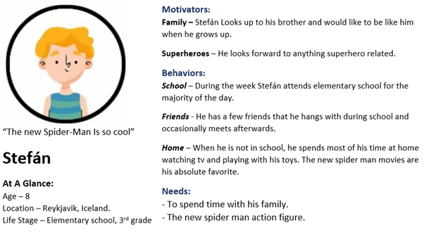

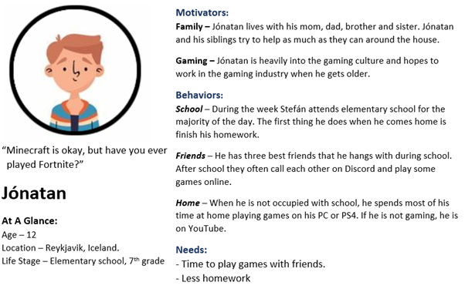

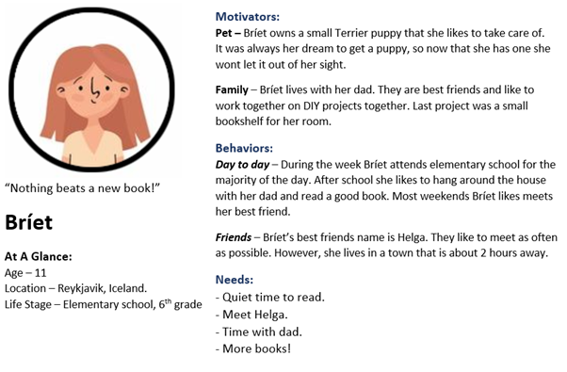

**Age 13 - 16**

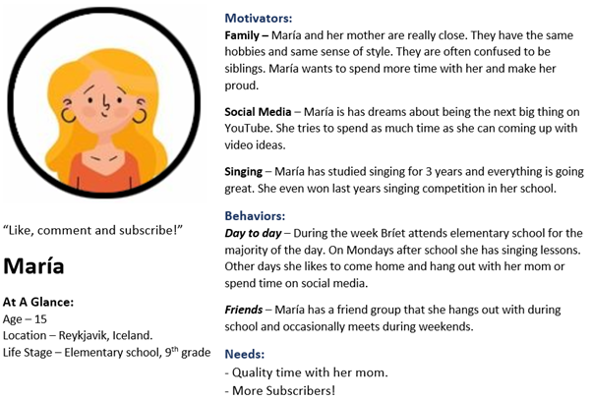

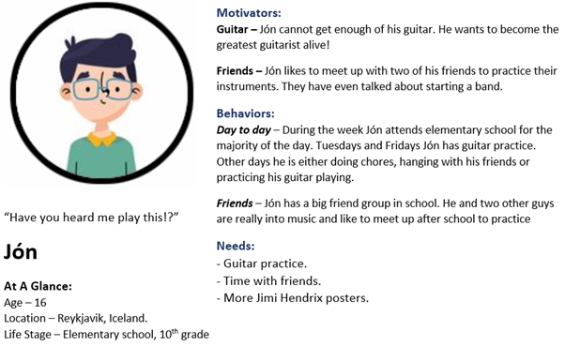

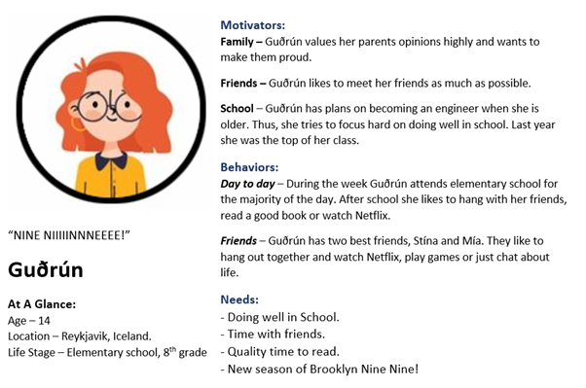

### Results

I found that for some of the personas there can be a great deal of overlap between boys and girls. Because of that, some personas can fit for both boys and girls and are not exclusive to either one. An example of this can be Jón in the 13-16 age demographic or Bríet in the 8-12 age demographic.

In my opinion seeing the personas laid out like this helps a lot with picturing possible end users for our app, and will help a lot with further design and development.

# **3 - Ideation and Sketching**

[Sketch Folder](https://drive.google.com/drive/folders/17yVPBIA-3VQszut1KBVJyQ2hEvpiXrgg?usp=sharing)

After the initial introduction to the project the group decided to meet a week later to share the results of our initial activity and ideas for the app. After some discussion on the pros and cons of each idea we narrowed the focus of the app significantly and decided to meet again a few days later with sketches for a second draft. The final sketches would be for an app that urges kids to go out and socialize with others through various challenges (some of which need to be done with other people).

For the second meeting ideas were still very varied but the group eventually decided on the final draft of the app. A trading card game where kids create cards for their deck by earning gems through challenges such as battling with a friend every day, and travelling to certain places for card drops. Battling friends every day creates a streak that increases the number of gems you collect.

# **4 - Prototyping**

Pétur took on the task of creating the prototype and Sigríður made the flow diagram.

## [Prototype](https://xd.adobe.com/view/694c079f-ac53-41ca-4c6f-7627fdb7d398-1f7d/screen/12b73628-8f98-4c82-a957-89d8e2e56a2d?fullscreen&hints=off)

To create the prototype for our project I used a software called **Adobe XD**.

**Adobe XD** is a prototyping tool that is commonly used by designers to test the user experience of an app before the development of the software. This allows the designer to quickly test their design, pinpoint potential difficulties and change anything that is out of place.

The following image shows you a design overview over the prototype in **Adobe XD.**

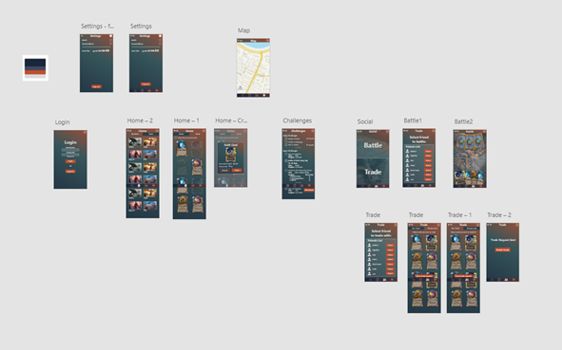

You can use the following link to test the prototype made for this project:  
<https://xd.adobe.com/view/694c079f-ac53-41ca-4c6f-7627fdb7d398-1f7d/?fullscreen&hints=off>

**For our prototype** I created a start to finish flow of the following tasks:

* Login.
* Settings window.
  + Separate settings window for the login screen and in app.
* Check Challenges.
  + Scroll to see all available and finished challenges.
  + See challenges on the map.
* Card Overview
  + You can see an overview of all the decks you own.
  + You can see an overview of all the cards you own.
  + You can press a card you do not own to craft it.
* Social
  + Battle
    - Select a friend from your friends list to battle.
    - See a prototype overview over the in-game battlefield.
  + Trade
    - Select a friend from your friends list to trade with.
    - See what cards you own and can trade with him.
    - See what cards your friend owns and can trade with.
    - Send a trade request.
      * “Trade Request sent. Finish Trade”
      * Go back to the Social menu.
* See the in-game map.

During any of the tasks, you can stop what you are doing and perform any other task.

For our prototype I used the following color pallet:



I got this color pallet from the following site:<https://colorsinspo.com/>

## Example flow

This example will show the flow from logging into the app, to battling your friends.

The example flow shown here is the same flow as is demonstrated in the flow diagram shown later in this chapter.

The first screen you see when you open the app is the following login screen:

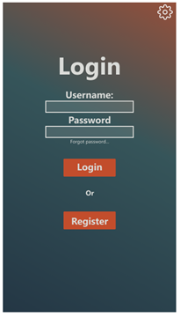

If you would type in your username and password and then press the Login button you would be presented with the following challenges screen:

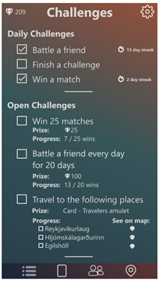

Now, to get to be able to challenge your friends to a battle, you have to select the „Social“ tab  down at the bottom of the screen.

If you press that button, you will be presented with the following screen:

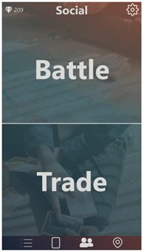

Now to battle your friend you select „Battle“ and are presented with your friends list.

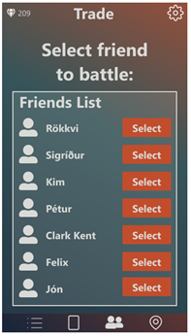

Select the friend you want to challenge, and go into the battle screen represented with the following image:

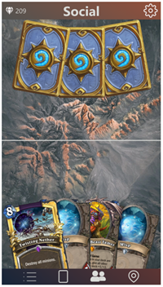

The battle game mechanic itself was not in the scope of this prototype.

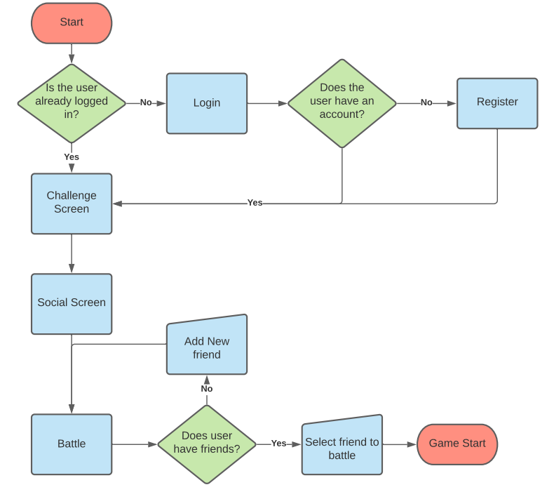

[Flow Diagram](https://drive.google.com/file/d/1BlXkaiaxagcWDId-mcJqueKP0nm6DaOg/view?usp=sharing)

## Results

I think the prototype was a success, it looks great and represents the idea well enough to be able to perform user tests and identify what, if anything, has to be changed.

Working in Adobe XD was really comfortable and being able to share the prototype with a link proved to be really good. I did have some former experience using it, but not to this extent. I will definitely use it again for future designs.

# **5 - User testing**

## **Ask 1 - Narration - Pétur**

The ask activity that I chose to perform is called “Narration”.

The activity consists of asking a user to perform a particular activity and describe everything they are thinking and doing aloud. According to the IDEO cards this can be a useful way to see the motivations and reasoning behind how the user performs an activity.

I think this activity can help us determine good qualities about other popular apps, that we might want to consider incorporating into our project. As well as pinpoint bad qualities that we might want to avoid.

### Participants

Unfortunately, at this point there are very few kids in my family and because of Covid-19 I don’t have access to friend’s family members. Because of that, only one participant fits our target demographic. There are three other users that participated in this study, but I think it can also be useful to see what they think about their favorite apps.

The following are the participants that took part in this study:

* Participant #1 – **Gunnar**
  + Age: 13
* Participant #2 – **Marín**
  + Age: 19
* Participant #3 – **Margrét**
  + Age: 61
* Participant #4 – **Kristmundur**
  + Age: 63

### The activity

For this activity I asked the participants to open their favorite app and perform the usual activities they would do in the app, while narrating what they are doing and why.

After the narration test is done, I asked the participants an additional question:

“Why is this your favorite app?”

### Results

The activity was performed in Icelandic and translated into English.

**Participant #1 – Gunnar**

*Gunnar*: “My favorite app is the YouTube app.”

*Gunnar*: “I’m opening the YouTube app and wondering if there is something interesting to watch”

*Gunnar*: “I go over the home screen and see if any of my favorite youtubers have new videos”

*Gunnar*: “If I don’t see anything interesting, I go into my subscriptions page and see if there are any

new videos there”

*Gunnar*: “And that’s it. Usually I find something on these pages. Otherwise I look at some random

video or do something else.”

*Pétur*: “Why do you consider this to be your favorite app?”

*Gunnar*: “Because it is fun.”

**Participant #2 – Marín**

*Marín*: “My favorite app is Spotify. I usually open it and see if there are any interesting new podcast

shows out.

*Marín*: “Or I go into my playlists and press shuffle or pick a song that I like listening to at this

moment. That’s about it.”

*Pétur*: “Why do you consider this to be your favorite app?”

*Marín*: “Because I love music!”

**Participant #3 – Margrét**

*Margrét*: “My favorite app is called Bubble pop Origin.

*Margrét*: “I usually just open the app and am immediately presented with the level in the game.

*Margrét*: “I press that and play while listening to the radio or watching tv.”

*Pétur*: “Why do you consider this to be your favorite app?”

*Margrét*: “Because I don’t really have to think while playing it. Can watch something while doing it.”

**Participant #4 – Kristmundur**

*Kristmundur*: “My favorite app is the internet browser.”

*Kristmundur*: “And in particular I mostly use it to go onto visir.is”

*Kristmundur*: “When I normally use it, I check to see the newest number of Covid cases in Iceland.”

*Kristmundur*: “And then I look to see if there are any interesting news”

*Pétur*: “Why do you consider this to be your favorite app?”

*Kristmundur*: “It’s good to stay updated on what is happening around us.”

### Conclusion

No participant had the same app, and it was interesting to see the different uses and experiences that everyone wanted to get out of their phones.

This activity has shown us that we need to have something that piques the user’s interest right away when opening the app. They have to be notified if there are any changes, for example in our app around the different challenges, or if there are any interesting updates.

Talking to the participants after the survey, most participants mentioned that they like their apps to be rather simple. They do not want any unnecessary complications or actions that take a long time.

## **Ask 2 - Extreme User Interview - Kim**

The chosen ask activity was the **Extreme User Interviews**. The interviews will focus specifically on two individuals, one who very often (over 3 times a week) plays digital card games, and one who almost never (less than once a month) plays digital card games. Both individuals were within the target age group of 13 - 16 year olds. This does leave a blind spot with regards to the age group of 8 - 12 year olds. It is therefore taken into account when drawing conclusions from the use of this method that the outcome might not necessarily reflect the outcomes of that, younger, target group.

The same set of questions were asked to both interview participants and it was made sure that both of them had access to the prototype at the time of interview. The participants will be referred to as “Infrequent Player”, and “Frequent Player” for clarity and privacy.

### Questions

**What makes you consider playing a digital card game?**

Infrequent Player:

“I don’t think there is anything specific that would make me want to play a card game. Perhaps I wouldn’t want it to be too hard to understand. If I was going to be convinced to play a card game then I think the most important thing has to be that a lot of my friends are playing it. I don’t enjoy playing games on my own or with strangers.”

Frequent Player:

“I want the game to not be too simple. I also want the game to have many ways you can play and to let you make different kinds of decks. It’s also good if the card game has a big community. A small thing that doesn’t matter too much but is still nice to have is good card designs. I like pretty cards.”

**What do you think about challenges, as presented in the prototype, in relation to a digital card game?**

Infrequent Player:

“To me it looks like a good way for me to be introduced to playing a card game. I used to play Pokémon Go with my friends and I always thought walking around and catching Pokémon was more fun than battling with them. It seems like this app offers a similar thing.”

Frequent Player:

“I really like the idea of challenges. Other card games I’ve played have had sort of similar challenges with battles and such, but none of them required you to do anything other than playing the game. I think it’s cool when games try new things and I could see myself going for a walk to get a new card just to have a reason to get out of the house.”

**What, to you, is the *most* appealing part about the prototype?**

Infrequent Player:

“Definitely the challenges that have you walking around. If there were more things like that in the game I think I might actually even convince my friends to download it with me.”

Frequent Player:

“I think it’s the fact that you’re combining a card game with the real world. I only played Pokémon Go for a short time but got bored because it’s such a simple game. But if you guys can make a complex card game that works like Pokémon Go I would be playing it from day one.”

**What, to you, is the *least* appealing part about the prototype?**

Infrequent Player:

“I think just the fact that it’s a card game. I don’t play many games at all and when I do it’s almost never a card game. But I can’t say I’ve given card games that much of a chance. Mostly because they always look so boring.”

Frequent Player:

“I can’t see anything about the prototype that is that unappealing, but I can see myself being a bit worried that playing the game can become a chore if I always have to move around to play it. It’s probably a lot more comfortable to just play my games on a computer instead of having to go for a walk to get new cards. At least in the long run.”

### Discussion and results

It came as a surprise how, in general, the two extremes were positively inclined towards the app. A suspicion as to why this would happen is that the prototype is (purposely) abstract as it misses a lot of features. This allows both of the extremes to project their own views of what the app, in its final state, will be. This is of course a caveat when testing and reviewing any incomplete product, though the outcome is still surprisingly - in a positive way.

It appears that the infrequent user had a strong preference not for the card game itself, but rather the content surrounding it. They prioritized the social aspects of the app, such as playing with friends.

On the flip side, while the frequent player cited the real-world aspects of the app as a benefit to the app they still saw how it could be the potential downfall, at least for players like them. The most important aspect of the app would be the card game itself, and then the surrounding activities should only serve as a way to break away from that core gameplay and enhance it.

It would be reasonable to say that there definitely exists a compromise that would satisfy both extremes. The product that is being designed is one that exists on two identifiable planes: the real world and the digital world. The real world is what appeals to the “casual” extreme and the digital appeals to the other, more competitive extreme. If we make both parts equally engaging and deep we can perhaps find ways to connect both extremes while also providing a solid foundation for a mass audience.

## **Try 1 - Scenarios - Sigríður Ösp**

For my try activity I chose to write Scenarios. This activity tasks you to illustrate a character-rich storyline describing the context of use for a product or service. In researching Scenarios I found that there’s a good amount of flexibility in the types of scenarios and their purpose towards the exercise. Essentially they’re meant to test the design idea in the context of using the app. In this case I chose to look at how the app could be used in a variety of contexts depending on the age of the users, their location, family, etc. to see how it could affect the way the app is used. Our goal with this app is to get children more active and social, can these scenarios affect the app’s ability to do so?

I’ll be referring to our app as the Card game in the scenarios as we don’t currently have a name for it.

### Scenarios

**Scenario 1 - Typical use, Teenager**

Jón (16, Reykjavík) woke up to his alarm blaring. 7:30, no time to press snooze, he’d slept through the first alarm again. After a quick breakfast he grabbed his school bag and guitar case and headed off to school. On his way to the bus station Jón ran into Fannar, his friend from down the street. While waiting for their bus they chatted about life and their plans for the weekend. School passed as usual but after their last class Jón brought Fannar and their other friend Stína back home to play their instruments together and have a mini Card game tournament. Jón won his first two games but after that his luck ran dry and he lost the last three. During the tourney they discussed their plans for the weekend. There was a special event happening in the game which required playing a game in three different parts of the city. The prize was a special card that was rarely seen ingame.

That weekend the trio grabbed their bikes and headed out to win that prize. The first stop was only about a 5 minute cycle away but the other two would take around 30 minutes each to reach. On their third stop (Laugardalshöll) they spotted another boy a few years younger than them with his phone out. Sure enough he was looking for other people in the area to play with to complete the challenge. After a couple of games and a long while chatting with the new boy they all exchanged social media info and planned to meet again in the future to help with challenges.

**Scenario 2 - Young user in a City**

Bríet (11, Cambridge) sat by the school building in the corner of the playground. She usually took a book along to recess cause there wasn’t much to do out there. She absolutely hated running and when you’ve got an exciting book you’ll use every chance available to get a few pages in. A few minutes into reading Bríet noticed a group of kids huddled together while a couple of other kids kept watch. Bríet had seen this before, they were doing something on their phones which was against the school rules. After watching for a while Bríet’s curiosity got the better of her and she walked over to see what they were up to. The kids were playing some sort of card game. The cards looked really interesting with their beautiful artwork. She asked the kids for the name of the game and wrote it down to install when she got home.

Later that day Bríet installed the game and had a look around the app. It looked very interesting but aside from looking at her cards and making decks there wasn’t much to do on your own. You needed other people to do battles and she wasn’t old enough to go out on her own so she couldn’t do the travel challenge. Bríet didn’t put much more thought into it until that weekend when she met up with her best friend Helga. All Helga talked about that weekend was the Card game. They played a few matches and Bríet was hooked! She continued to play with her classmates at her school the following weeks. She tried her best to keep up the daily battle streak but since she usually stayed home with her dad on weekends she’d often lose it.

**Scenario 3 - Multiple users in a home**

The day started with a big squabble at the breakfast table at Stefán (8, Reykjavík) and Jónatan’s (12) house. Stefán had taken to copying Jónatan’s mannerisms which annoyed Jónatan to no extent! Once things calmed down the boys finished their breakfast and piled into the living room to play the new Spider Man game. After some time Stefán pointed out that they hadn’t gotten their daily streak in the Card game today. The boys had been extremely diligent in keeping up their daily streaks. Every day they would play a few games, making sure they would purposely win at least one each to keep their daily win streak. Jónatan was especially diligent in this. He hated going out so having a brother to play with every day was extremely useful.

While browsing the Card game app Jónatan noticed that the card he’d been after for 3 months was up as a prize for the game’s travel challenge. As much as he hated to admit it he REALLY wanted that card! Later that day he finally gave in and decided to make the journey to the three locations listed in the challenge. Upon arriving at the first location (Laugardalshöll) Jónatan had a realization: He didn’t have anyone to play with. While fretting and trying to decide what to do he noticed three older kids arriving and pulling out their phones. The kids greeted Jónantan and invited him to play a few games with them. After a few games and a fun conversation he headed off to the next location, excited to see what the adventure would bring.

**Scenario 4 - Access Difficulties**

María (16) sat at her desk umming and ahhing over a notebook. She was trying to think of what to talk about on her next Youtube video. Last year, María had started a Youtube channel to give people more insight into the life of a chronically ill teenager. Recently her Youtube channel had started getting more traction but she wasn’t sure what the audience would want to see next. She was desperate for some ideas so she messaged her friend Jenní asking for suggestions. After some thought Jenní suggested maybe doing some reviews, for example of games, make up, books, etc. María thought this was an excellent idea and immediately started researching. After some browsing she decided to try the new Card game that had gotten so popular in the past few weeks.

Since the game required two players María asked her mom to try it out with her. They had lots of fun learning how the game works and started playing a few matches together every morning before classes started. Although playing with her mom was great fun, María wished she could play remotely as well since she wasn’t able to see her friends much at the moment because of her illness. She also had issues with some of the travel challenges since she wasn’t able to walk for very long and would need to bring her wheelchair, which was a whole other set of travel issues. Her mom was willing to help sometimes but driving to various locations every week just to play a card game was out of the question. In the end María was able to make a very informative Youtube video about the pros and cons of the Card game for people with disabilities.

### Conclusions

Through creating these scenarios there were several ideas and issues that came up that I feel could be looked at for future versions of the product.

In scenarios 2 and 4 we see that going out and doing travel type challenges may not be possible for younger kids, kids in big cities, and kids with limited mobility. As such it would be important to make sure that there is good variety in the larger challenges that offer prizes so everyone has a chance to win at least some of them.

In scenario 3 I encountered an interesting issue I hadn’t thought of before. Is it possible to play the system? If you have other players at home and you can do the daily challenges there would that defeat the point of the app since you’re not going out? Would we want to avoid that scenario? I would argue that it’s still getting people together and being social so it’s not a big issue but if we would like to avoid that one idea would be that you can’t battle the same person two days in a row for the daily challenges.

Finally, in scenario 2 I noticed that there is very little content in the game for single players. Since this is an app created to get kids socializing and getting out more one could argue that single player content isn’t really needed but if we look at scenario 2 for example, Bríet installs the game when she’s alone, only to realize that there isn’t really anything for her to do since she can’t go out on her own. This kind of situation could mean that the kid could lose interest in the app and not pursue it any further. A beginners tutorial and maybe some single player content would help kids get more situated with the playstyle and get them excited about playing other people. It also got me thinking of scenario 4, kids that have limited mobility and studying from home. How would the app be used by them? It would be great to have remote play options but that would kind of defeat the point of the app since kids could just play it at home. How could we make the app and challenges more accessible for kids with limited mobility?

## **Try 2 - user testing - Rökkvi**

I did a user test with one of the participants in our user group. Before the user test was done I prepared by creating an interview guide. The interview guide helps me keep an overview of what I have to cover but I avoided reading straight out of the interview guide. It is more like a script I use beforehand. I created tasks for the user to complete and then checked if there are any problems with the prototype that stand out. I then created questions that cover the background of the user. I asked the user questions that were of importance to fit the user group. After that I had questions regarding Usability and Experience of the prototype. I plan on recording the test so I can review the outcome afterwards. Since the user is under 18 I decided to just to just record the sound when I ask the questions and record the screen while the user completes the tasks.

### Conclusions

I started the interview by going over the interview guide, then I explained how I was going to record the interview and the user gave a green light on recording. We went over the tasks, the things that popped up when we were doing them was that the icons could be a bit more expressionist and the first screen that comes up when the user logged in was a "bit weird". That said, overall the tasks went well and the user completed them all. Then I asked the user some background questions and questions related to usability and experience. The outcome from the questions was quite positive showing that the user would like to use the app quite often as well it was fun to use.   
 We have created a good core in this project we just need to build on top of what we got. small adjustments have to be made to the prototype like changing the icons and some fixes, I'm really optimistic with the project but I would have liked to take more user tests both male and female as well as taking users from different age group

### Interview guide

"Velkomin takk fyrir að gefa þér tíma í að skoða þetta verkefni, til að kynna verkefnið aðeins þá erum við í hópverkefni í áfanga í HÍ þar sem við eigum að reyna koma með forrit fyrir síma sem lætur krakka eyða minni tíma fyrir framan sjónvarpið heima hjá sér, fara oftar út og auka félagslífið. Forritið sem ég er að fara sýna þér er leikur þar sem þú átt að fara út til að finna spil, þegar þú finnur spilin getur þú sett þau í safnið þitt. þú notar svo spilin sem þú hefur safnað þér til að spila við aðra notendur. Þetta er frumgerð sem ég er að fara sýna þér þannig þetta er alls ekki loka útkoman. Ég læt þig fá nokkur verkefni sem þú átt að leysa en ég er engan vegin að prófa þig heldur er ég að skoða hvort það sé auðvelt og notendavænt að nota forritið. Þú þarft ekki að leysa öll verkefnin og mátt hætta hvenær sem er. Ég ætla taka þetta upp til að hjálpa mér að vinna betur úr þessu viðtali ef það er í lagi þín vegna.

Eftir að við erum búin að fara yfir töskin þá er ég með nokkrar spurningar um forritið sem ég ætla biðja þig um að svara en þær tengjast notagildi og notendaupplifun á forritinu, eins og ég minntist á þá byrjum við að leysa þessi svokölluðu tösk en á meðan þú leysir töskin ætla ég að biðja þig um að hugsa upphátt semsagt segja allt sem þú ert að hugsa meðan þú leysir verkefnin, og enn og aftur vill ég minna á að ég er ekki að prófa þig á neinn hátt bara skoða hvernig prótótýpan er. Ég semsagt tek upp hljóðið þegar við förum yfir spurningarnar og svo tek ég upp skjáinn þegar þú ferð í töskin"

**Tasks**

Þú ert með aðgang og átt að skrá þig inn

þú vilt sjá yfirlit yfir öll töskin eða challenges sem eru í boði

þú vilt sjá öll spilin sem þú átt

þú vilt keppa við Rökkva með bunkanum þínum

þú vilt fara í mappið og sjá hvort það eru einhver spil nálægt þér

þú vilt skrá þig út

**Background questions with answers**

hver er aldur þinn : 15 ára

kyn : kvk

áttu snjallsíma eða spjaldtölvu ? já síma

finnst þér þú eyða miklum tíma fyrir framan tölvuskjá eða sjónvarp? já

myndiru segja að þú farir oft út að hitta aðra krakka? já myndi segja það

**Questions regarding Usability and experience with answers**

Þessar spurningar eru á skalanum frá 1 til 5 þar sem 1 er ósammála og 5 er sammála.

1. Ósammála
2. Frekar ósammála
3. Hvorki né
4. Frekar sammála
5. Sammála

Usability / notagildi:

1. Myndir þú vilja skoða forritið reglulega? 4
2. Fannst þér forritið óþarflega flókið? 2
3. Fannst þér forritið auðvelt í notkun? 4
4. Heldur þú að þú þyrftir aðstoð við að nota forritið? 1
5. Fannst þér einhver virkni á forritinu vel útfærð? 5
6. Fannst þér of mikið ósamræmi í forritnu? 1
7. Heldur þú að flestir myndu vera fljót að læra á forritið? 4
8. Fannst þér forritið óþægileg í notkun? 1
9. Leið þér vel að nota forritið? 5
10. Heldur þú að þú myndir þurfa læra mismunandi hluti til að geta nýtt þér forritið? 3

Experience/upplifun

1. á skalanum 1-5 (1 verandi flókin og 5 verandi auðveld) hvernig fannst þér forritið í notkun? 4
2. Á skalanum 1-5 ( 1 verandi óskilvirkt og 5 verandi skilvirkt) hvernig fannst þér forritið í notkun) 5
3. Á skalanum 1-5 ( 1 verandi ruglandi og 5 verandi skýr) hvernig fannst þér forritið í notkun? 4
4. Á skalanum 1-5 ( 1 verandi leiðinleg og 5 verandi skemmtileg) hvernig fannst þér forritið í notkun ? 5
5. Á skalanum 1-5 ( 1 verandi ekki áhugaverð og 5 verandi áhugaverð) hvernig fannst þér forritið í notkun 5
6. Á skalanam 1-5 ( 1 verandi hefðbundin og 5 verandi frumleg) hvernig fannst þér forritið vera ? 5

# 

# **6 - Conclusions and recommendations**

Much like the first assignment, this group project went very well. Everyone was enthusiastic about our app idea which resulted in great discussions at meetings. It was interesting to see how the app changed from our initial sketches through to the end product.

The Ask and Try activities resulted in some excellent suggestions for future iterations of the app. There are several changes that would be useful such as making the starting screen more eye catching and interesting, and simplifying the buttons and tasks. As to possible additions to the app some examples would be adding notifications and events, tutorials, and looking further into designing the card game itself. Finally, it would be interesting to do further research in regards to accessibility and usability.

As it is, the app is still in very early stages and missing key features. As Kim mentioned in his Ask activity; because the app is still very abstract it’s easier for users to project their own opinions on what the final product would look like. That said, the interest seems to be there and the test participants showed great enthusiasm for the project.

1. <https://childmind.org/article/how-using-social-media-affects-teenagers/>
2. <https://9to5mac.com/2019/12/16/apps-and-games-of-the-decade/>